Machine Learning Assessment of Seasonal Climate Anomalies and County-Level Maize Yield in Kenya: A 2026 Short-Rains Forecast Scenario
Author: Debra Mathilo · Prepared October 2026 · Draft for review

Abstract
This project examines how maize yield in Kenya's 47 counties responds to climate anomalies in the March–May (MAM, long rains) and October–December (OND, short rains) seasons, and what the 2026 OND seasonal forecast implies for yield. County maize yield (KNBS/Kilimodata, 2012–2020, 376 county-years) was linked to seasonal temperature and rainfall from ERA5-Land, summarised per county as raw values and anomalies. A random forest was evaluated with leave-one-year-out cross-validation and with a holdout of the 2015/16 El Niño years. Adding MAM climate to the OND features raised the 2015/16 holdout R² from 0.18 to 0.39 and the leave-one-year-out R² from 0.33 to 0.39. For 2026, observed MAM (ERA5-Land) was combined with the OND SEAS5 forecast, expressed as an anomaly against SEAS5's own hindcast climate and added to each county's observed baseline, which cancels the forecast model's bias and its coarser grid. Under a wetter and warmer than normal OND forecast, the model predicts yield gains in 28 of 47 counties, largest in coastal and central highland counties, and losses in the other 19, mainly in the Lake Victoria basin, western Kenya and parts of the arid north and east. The results are exploratory: model skill is modest, yield is an annual figure, the record is short, and the western losses are sensitive to the model's reliance on raw temperature.

1. Introduction and objectives
Maize is Kenya's main staple, and its production depends strongly on the timing and amount of rainfall. East African rainfall in the October–December short rains is modulated by large-scale climate drivers, and El Niño years such as 1997/98 and 2015/16 are typically associated with wetter than normal OND conditions. The original aim of this project was to learn the climate–maize relationship from those two Super El Niño events, apply it to the 2026 seasonal forecast, and map the expected impact across East Africa.
The scope was revised as the data were examined:
- East Africa was narrowed to Kenya, because maize calendars differ between countries and sub-national yield data had to be sourced country by country.
- The 1997/98 event could not be used, because no clean county-level yield record for that period was found. The usable record covers 2012–2020, so 2015/16 is the only Super El Niño event in the analysis.
- Climate was first limited to OND, then extended to include MAM, because the yield data proved to be annual totals (Section 2.2).
The objectives were therefore: (1) build a county-level dataset linking seasonal climate to maize yield; (2) train and evaluate a machine learning model; (3) test whether it reproduces yield variation in the 2015/16 El Niño years; and (4) apply it to 2026 climate inputs to produce baseline, predicted and impact maps for the 47 counties.

2. Study area and data

2.1 Study area
Kenya, analysed within the bounding box 5.5°N to 5°S and 33.5°E to 42°E. The country spans arid and semi-arid lands in the north and east, humid highlands in the centre and west, the Lake Victoria basin, and the coast.

2.2 Maize yield
County maize area (ha), production (t) and yield (t/ha) came from the KNBS/Kilimodata dataset Maize Production by County 2012–2020. It covers all 47 counties for 2012–2018 and 2020 (2019 is absent), giving 376 county-year observations with yield. The file holds one record per county per year and has no season field, so yield is treated as an annual total covering the long and short rains. This is inferred rather than documented: the highest yields occur in Uasin Gishu and Trans Nzoia (about 3.9 t/ha in 2015 and 2016), which are long-rains counties, and FAO GIEWS reporting puts long-rains maize at about 80% of annual national output.
Two records, Wajir 2016 (0.000 t/ha) and Mombasa 2016 (0.100 t/ha), look like possible placeholder values. They were confirmed to be recorded that way in the source and were retained.

2.3 Historical climate
ERA5-Land monthly averaged reanalysis (0.1° grid) was downloaded from the Copernicus Climate Data Store for 2012–2020: 2 m temperature and total precipitation for OND and for MAM. Soil moisture (layer 1) and potential evaporation were also downloaded for OND and used in an initial model, but were later removed (Section 3.6).

2.4 County boundaries
A 47-county shapefile in WGS84 was used. One unnamed artifact polygon was removed, names were title-cased and trimmed, and four were harmonised with the yield file (Elgeyo/Marakwet, Tharaka-Nthi, Homabay, Taita/Taveta).

2.5 2026 climate inputs
- OND 2026 forecast: ECMWF SEAS5 (system 51) ensemble mean from the Copernicus C3S seasonal monthly single-levels dataset, initialised in October 2026, lead months 1–3 (October–December), at 1° resolution.
- SEAS5 hindcast climate mean: the same dataset's hindcast climate mean product for the same start month and lead times, a model climatology over 1993–2016.
- MAM 2026: observed ERA5-Land values for March–May 2026, which had already occurred.

3. Methods

3.1 Workflow
- Convert the climate files to seasonal values and average them within each county.
- Compute anomalies relative to each county's own mean.
- Merge climate features with annual county yield.
- Train and evaluate a random forest.
- Build the 2026 inputs from observed MAM and the corrected OND forecast.
- Predict yield under three scenarios and map the results.

3.2 Seasonal aggregation and units
ERA5-Land monthly means store temperature in kelvin and precipitation as the mean daily accumulation in metres. Temperature was converted to °C and averaged over the three months of a season. Precipitation was multiplied by the days in each month and by 1000 to give monthly totals in mm, then summed to a seasonal total. The SEAS5 files give precipitation as a rate (m/s), converted by multiplying by the seconds in each month. Evaporation follows the ECMWF sign convention (negative) and was sign-flipped where used.

3.3 Zonal statistics
For each county, the grid cells whose centres fall inside the county polygon were averaged using the regionmask package. On the 0.1° ERA5-Land grid every county contains cells. On the 1° SEAS5 grid only 23 counties contain a cell centre; the other 24 were assigned the cell nearest the county centroid, so neighbouring counties often share identical values.

3.4 Anomalies and features
An anomaly is a season's value minus that county's 2012–2020 mean for the same season, using all nine years including 2019. The final model has eight features: OND temperature, OND rainfall and their two anomalies, and the same four for MAM. The target is annual county maize yield in t/ha.

3.5 Model and evaluation
A random forest regressor (scikit-learn) was used, with 300 trees, a fixed random seed (42) and otherwise default settings. Two evaluations were run:
- Leave-one-year-out cross-validation: train on seven years, predict the held-out year, repeat for each of the eight years with yield. This is fairer than random splits because the same counties appear in every year.
- El Niño holdout: train without 2015 and 2016, then predict those two years.
Metrics are R², mean absolute error (MAE) and root mean square error (RMSE).

3.6 Variable choices and handling of the 2026 forecast
Two decisions shaped the final design.
Soil moisture and evaporation were dropped. The seasonal monthly forecast dataset has no soil moisture, and its evaporation is actual rather than potential evaporation. Forecast evaporation was about 130–360 mm for the 2026 season, against 690–960 mm of potential evaporation in the training data, so the two are not comparable.
OND anomalies were computed against SEAS5's own hindcast. A first attempt compared raw SEAS5 values with the ERA5-Land baseline. This produced implausible temperature anomalies of about −2.4 to +5.0 °C, caused by the 1° versus 0.1° grid and by forecast model bias, and impact estimates above +100% in several counties. In the final method, the OND 2026 anomaly is the SEAS5 2026 forecast minus the SEAS5 hindcast climate mean, and the model input is the county's observed 2012–2020 ERA5-Land OND mean plus that anomaly. MAM 2026 uses observed ERA5-Land values with the anomaly taken against the 2012–2020 MAM mean.

3.7 Scenarios and impact
The model was trained on all 376 county-years and applied to three inputs:
- 2026: OND forecast anomalies plus observed MAM 2026 anomalies.
- Baseline: each county at its 2012–2020 mean in both seasons, with all anomalies zero.
- OND-only: OND forecast anomalies with MAM held at normal, to isolate the short-rains effect.
Impact (%) is (scenario − baseline) / baseline × 100, computed only where the baseline exceeds 0.1 t/ha. The baseline is a model prediction for an average-climate year, not an observed average yield. Maps are county choropleths with banded colour classes.

4. Results

4.1 Model performance
Model | Features | Leave-one-year-out R² | 2015/16 holdout R² | Holdout MAE (t/ha)
A | OND only, 8 features (including soil moisture and evaporation) | 0.443 | 0.270 | 0.571
B | OND only, 4 features (temperature, rainfall and anomalies) | 0.327 | 0.177 | 0.615
C (final) | OND + MAM, 8 features (temperature, rainfall and anomalies) | 0.389 | 0.393 | 0.546
Model B is the OND-only version restricted to variables the 2026 forecast can supply. Adding MAM (Model C) recovers performance and more than doubles the El Niño holdout skill relative to B (0.177 to 0.393). It also exceeds Model A on 2015/16, even though A had two extra variables. Model C's per-year leave-one-year-out R² is stable, between 0.33 and 0.44 (2015: 0.393, 2016: 0.390), whereas Model A ranged from 0.21 to 0.58 (2016: 0.213). Model C's leave-one-year-out MAE is 0.559 t/ha and RMSE 0.715 t/ha. The overall leave-one-year-out average is still lower than Model A's (0.389 versus 0.443). The holdout rests on only two years (94 observations), so it is an imprecise estimate.

4.2 Feature importance
In the final model, MAM rainfall carries the most weight (0.247), followed by OND temperature (0.209), OND rainfall (0.137) and MAM temperature (0.102). The four anomaly features together contribute about 0.31. The high weight on MAM rainfall is consistent with annual yield being mostly long-rains maize. The large weight on raw temperature, which acts as a proxy for elevation and hence for which county is being predicted, indicates the model partly recognises counties by their climate rather than learning only how yield responds to anomalies.

4.3 Where the model errs in 2015/16
The model underpredicts the highest-yield counties: Trans Nzoia (observed 3.87 versus predicted 2.05 t/ha in 2015; 3.82 versus 2.84 in 2016) and Uasin Gishu (3.89 versus 2.77; 3.95 versus 2.40). In 2016 it overpredicts several counties where yield fell: Kirinyaga (0.87 versus 2.09), Kisii (1.31 versus 2.56), Bomet (1.41 versus 2.47) and Laikipia (0.17 versus 1.32). The model tends to regress toward typical county values and underestimates extremes, as is common for random forests trained on small samples.

4.4 2026 climate inputs
After the hindcast correction, OND 2026 temperature anomalies range from +0.43 to +1.72 °C (mean +1.02 °C), and rainfall anomalies from +9 to +161 mm (mean +92 mm): every county is wetter than the forecast model's normal. MAM 2026, observed, had temperature anomalies from −0.56 to +0.03 °C (mean −0.28 °C) and mixed rainfall anomalies from −128 to +152 mm (mean −4 mm). A wetter and warmer OND is the usual direction of the East African short-rains response to El Niño, but this project did not independently verify the 2026 ENSO state. The temperature anomaly is probably overstated, because part of it reflects long-term warming since the 1993–2016 hindcast period.

4.5 Predicted yield and impact
Figure 1 (kenya_2026_maize_maps_final.png) shows four panels: predicted 2026 yield, baseline yield, total impact (observed MAM plus forecast OND), and OND-only impact.
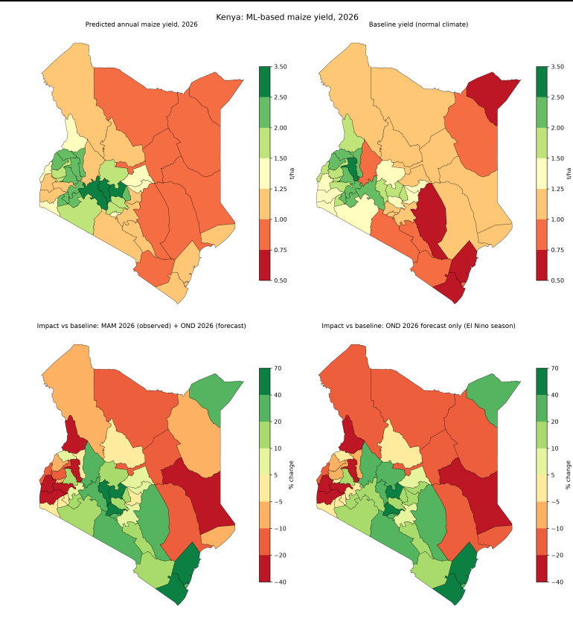
Yield. Baseline yield ranges from about 0.6 to 3.1 t/ha. It is highest in Uasin Gishu (3.07) and the western and central highlands (about 2.0–2.3 t/ha), and lowest in Kilifi, Kitui, Mandera and Kwale (about 0.6–0.7 t/ha). Predicted 2026 yield ranges from about 0.8 t/ha in the arid east to 2.9 t/ha in Nakuru.
Impact. Under the OND-only scenario, 28 of 47 counties gain and 19 lose. The largest gains are in coastal and central counties: Kilifi (+65%), Kiambu (+62%), Nyeri (+55%), Kwale (+52%), Nyandarua (+39%), Kitui (+37%) and Mombasa (+32%). Losses of roughly −16% to −22% appear in Siaya, Garissa, Uasin Gishu, Homa Bay, Kisumu, West Pokot, Busia, Marsabit and Tana River.
Adding observed MAM 2026 changes few counties. The OND forecast therefore drives most of the pattern. The largest MAM effects are in Embu, where a dry MAM (−115 mm) turns an OND-only gain of +17% into −5%, and Tharaka-Nithi (+18% to +8%). A wetter MAM raises Nakuru's gain from +20% to +31%.

5. Discussion
What the model captures. Out of sample, the climate features explain roughly 39% of the variation in county-year yield. MAM rainfall matters more than any OND variable, which reflects the annual yield target: most of the maize that year is grown in the long rains. A direct test of the El Niño effect on short-rains maize would need season-specific yield data, which was not available.
Plausibility of the 2026 pattern. Extra rainfall helping water-limited coastal and southeastern counties is agronomically sensible, so the gains are the more credible part of the map. The western losses coincide with the largest OND temperature anomalies (+1.3 to +1.7 °C), and the model leans on raw temperature as a county proxy, so a warm shift may push western counties toward the lower-yield range the model associates with other places. Uasin Gishu falling by about 22% from the highest baseline is the clearest example. Waterlogging or harvest losses under an already wet OND could also reduce yield in the west, but the model has no mechanism for such effects, so this remains a hypothesis.
Why the correction matters. Before the hindcast correction, the same pipeline gave temperature anomalies of −2.4 to +5.0 °C and impacts such as +230% in Nyeri and +143% in Kwale. After the correction, anomalies are within a plausible range and impacts mostly fall between −26% and +66%. Comparing forecasts directly with a reanalysis baseline of different resolution and a different model would have produced misleading maps.
What can be claimed. The results support a statement that, under the 2026 OND forecast of wetter and warmer than normal conditions, the model projects yield gains in water-limited central, southeastern and coastal counties and uncertain losses in the west.

6. Limitations
- Season mismatch. Yield is annual, while the features include only two seasons. The OND signal that motivated the study is diluted by the long-rains harvest.
- Short record, one event. There are only eight years of yield (2012–2018 and 2020), and 2015/16 is the only Super El Niño. The 1997/98 event is not covered, and the two-year holdout is a weak basis for conclusions.
- Yield data quality. The estimation method of the administrative statistics is not documented here. 2019 is missing, and two 2016 values (Wajir 0.000, Mombasa 0.100) may be placeholders.
- Modest skill and compressed extremes. R² is about 0.39, and the model underpredicts the highest yields and overpredicts some low-yield cases.
- Raw-temperature shortcut. Anomaly features carry only about 31% of the importance, so county identity influences the predictions. A yield-anomaly model was not run and would be a useful sensitivity test.
- Forecast input. A single model (SEAS5), the ensemble mean only (no spread), a 1° grid shared by neighbouring counties, a hindcast period (1993–2016) that differs from the 2012–2020 baseline, and no assessment of forecast skill for this season.
- Omitted drivers. Soil moisture, evaporation, planting dates, management, inputs, pests, prices and soils are not represented, and no crop model was used.
- ENSO not explicit. The model sees only temperature and rainfall. Whether 2026 is an El Niño year was not checked.
- County-level resolution. Outputs are one value per county. Percentage impacts are unstable where the baseline is low, as in much of the arid north and east.
- Baseline definition. The normal climate is a nine-year mean (2012–2020), which includes the 2015/16 El Niño, not a long-term climatology.

7. Conclusions
A county-level pipeline linking ERA5-Land climate to Kenyan maize yield was built and tested. Including both the long and short rains improved skill, particularly in the 2015/16 El Niño years (holdout R² 0.39). Combining observed 2026 MAM with a bias-corrected OND 2026 forecast produced county maps of baseline yield, predicted 2026 yield and impact. They suggest gains in coastal and central counties and losses mainly in the west and parts of the arid north and east. The method is reproducible and the main weaknesses are identified, but because of the modest skill, the annual yield target and the short record, the results should be read as an exploratory scenario rather than a forecast of yield.

8. Recommendations for further work
- Obtain season-split (long rains and short rains) county yields, for example from KNBS National Agriculture Production Reports, so the OND effect can be tested directly.
- Extend the record, including district-level data for 1997/98, to add a second Super El Niño event.
- Run a yield-anomaly model and a leave-one-county-out evaluation to test whether the western losses survive without the raw-temperature shortcut.
- Use the full SEAS5 ensemble to show forecast uncertainty, and add other forecast systems.
- Verify the 2026 ENSO state and the forecast's skill for the OND season.
- Test other models and tune hyperparameters, and add soil moisture or satellite vegetation indices where they can be supplied consistently for 2026.
- Match the hindcast and baseline periods, or detrend, to remove the warming offset.

9. Reproducibility
Scripts are run in this order:
- ond_county_features.py: OND grid to county values and anomalies.
- merge_yield_climate.py: merge climate features with yield.
- mam_county_features.py: MAM county features, merged into the dataset.
- train_evaluate_model.py: model training and evaluation (leave-one-year-out and 2015/16 holdout).
- predict_2026_and_map.py: 2026 inputs, scenarios, predictions, CSV and maps.
Software: Python with xarray, geopandas, regionmask, scikit-learn, matplotlib and cdsapi. Climate data require a free Copernicus Climate Data Store account.

References
- Breiman, L. (2001). Random forests. Machine Learning, 45, 5–32.
- Johnson, S. J. et al. (2019). SEAS5: the new ECMWF seasonal forecast system. Geoscientific Model Development, 12, 1087–1117.
- Muñoz-Sabater, J. et al. (2021). ERA5-Land: a state-of-the-art global reanalysis dataset for land applications. Earth System Science Data, 13, 4349–4383.
- Pedregosa, F. et al. (2011). Scikit-learn: machine learning in Python. Journal of Machine Learning Research, 12, 2825–2830.
Data sources: KNBS/Kilimodata, Maize Production by County 2012–2020; Copernicus Climate Data Store, ERA5; FAO GIEWS country briefs for Kenya.

